Department of Electrical Engineering
The Superior University, Lahore

Computer Programming

Experiment No.11
Utilization of Arrays and Functions

Prepared for:
EISHA NAWAZ
By:
Name: Tanseer Haider
ID: SU91-BSEEM-F25-02
Section: Electrical Engineering Fall 25
Semester: 2nd

Total Marks: ______10_________
Obtained Marks: ______________
Signature: __________________
Date: __________________

Experiment No.11
Utilization of Arrays and Functions
(Rubrics)

Name: Tanseer Haider ID: SU91-BSEEM-F25-02

- PSYCHOMOTOR
Serial No. | Criteria | Allocated Marks | Unacceptable  0% | Poor  25% | Fair  50% | Good  75% | Excellent  100% | Total Obtained
1 | Syntax handling | 1 | 0 | 0.25 | 0.5 | 0.75 | 1
2 | Program Coding Skills | 2 | 0 | 0.5 | 1 | 1.5 | 2
3 | Accuracy in Output Results | 3 | 0 | 0.75 | 1.5 | 2.25 | 3
Sub-Total |  | 6 | Sub Total Marks Obtained in Psychomotor (P)

- AFFECTIVE
Serial No. | Criteria | Allocated Marks | Unacceptable  0% | Poor  25% | Fair  50% | Good  75% | Excellent  100% | Total Obtained
1 | Assigned Tasks | 2 | 0 | 0.5 | 1 | 1.5 | 2
2 | Lab Report | 2 | 0 | 0.5 | 1 | 1.5 | 2
Sub-Total |  | 4 | Sub Total Marks Obtained in Affective (A)

Instructor Name: | EISHA NAWAZ | Total Marks (P+A): | _____10_______
Instructor Signature: | ______________ | Obtained Marks (P+A): | ______________
Contents of Lab 11
1 Objectives 4
2 Passing Arrays To A Function in C++ 4
2.1 Syntax For Passing Arrays As Function Parameters 4
2.1.1 Example 1: Passing 1D Array to A Function 4
2.2 Passing Multidimensional Array to A Function 6
2.2.1 Example 2 6
2.3 Returning Array From A Function 7
2.4 Passing String To A Function 7
2.5 Function Overloading 8
2.5.1 Example: Overloading Using Different Types of Parameters 8
2.5.2 Example: Overloading Using Different Number of Parameters 9
2.6 C++ Default Arguments 11
2.6.1 Working of Default Arguments 11
2.6.2 Example: Default Argument 12
2.7 Things To Remember 13
3 C++ Storage Class 14
3.1 Example 1: Local variable 15
3.2 Global Variable 15
3.2.1 Example 2: Global variable 16
3.3 Static Local variable 16
3.3.1 For example: 16
3.3.2 Example 3: Static local variable 17
4 Lab Tasks 18
4.1 Task 1 18
4.2 Task 2 18
5 Home Assignment: 18
5.1 Task 1 18

Utilization of Arrays and Functions

Objectives
- Learn how to pass 1D and multidimensional arrays as function parameters.
- Understand how strings are passed to functions.
- Learn function overloading giving multiple functions the same name.
- Use default arguments to make function calls more flexible.
- Understand storage classes: local, global, and static variables.

Passing Arrays To A Function in C++
In this tutorial, we will learn how to pass a single-dimensional and multidimensional array as a function parameter in C++ with the help of examples.
In C++, we can pass arrays as an argument to a function. And, also we can return arrays from a function.
Before you learn about passing arrays as a function argument, make sure you know about C++ Arrays and C++ Functions.

Syntax For Passing Arrays As Function Parameters
When you call the function, you pass just the array's name — no brackets, no size.
The syntax for passing an array to a function is:
returnType functionName(dataType arrayName[arraySize]) {
// code
}
Let's see an example,
// Example
int total(int marks[5]) {
// code
}
#include <iostream>
using namespace std;

void display(int m[5])
{
cout << "Displaying marks: " << endl;
for (int i = 0; i < 5; ++i)
cout << "Student " << i + 1 << ": " << m[i] << endl;
}

int main()
{
int marks[5] = {88, 76, 90, 61, 69};
display(marks); // just the array name is passed
return 0;
}
Output
Displaying marks:
Student 1: 88
Student 2: 76
Student 3: 90
Student 4: 61
Student 5: 69

ℹ Tip: When you pass an array, the function actually receives the memory address of its first element. This means any changes the function makes to the array elements affect the original array in main() too — unlike ordinary variables, which are passed by value.

Example 1: Passing 1D Array to A Function
An example of declaration of an array is given as follows:
Code | Output
// C++ Program to display marks of 5 students  #include <iostream>  using namespace std;  // declare function to display marks  // take a 1d array as parameter  void display(int m[5]) {  cout << "Displaying marks: " << endl;  // display array elements  for (int i = 0; i < 5; ++i) {  cout << "Student " << i + 1 << ": " << m[i] << endl;  }  }  int main() {  // declare and initialize an array  int marks[5] = {88, 76, 90, 61, 69};  // call display function  // pass array as argument  display(marks);  return 0;  } | Displaying marks:  Student 1: 88  Student 2: 76  Student 3: 90  Student 4: 61  Student 5: 69

Here,
- When we call a function by passing an array as the argument, only the name of the array is used.
display(marks);
Here, the argument marks represent the memory address of the first element of array marks[5].
- However, notice the parameter of the display() function.
void display(int m[5])
Here, we use the full declaration of the array in the function parameter, including the square braces [].
- The function parameter int m[5] converts to int* m;. This points to the same address pointed by the array marks. This means that when we manipulate m[5] in the function body, we are actually manipulating the original array marks.
C++ handles passing an array to a function in this way to save memory and time.

Passing Multidimensional Array to A Function
A 2D array can be passed the same way. The number of rows can be left out of the parameter, but the number of columns must always be specified.

Example 2
Following is an example to assign a single element of the array:
Code | Output
// C++ Program to display the elements of two  // dimensional array by passing it to a function  #include <iostream>  using namespace std;  // define a function  // pass a 2d array as a parameter  void display(int n[][2]) {  cout << "Displaying Values: " << endl;  for (int i = 0; i < 3; ++i) {  for (int j = 0; j < 2; ++j) {  cout << "num[" << i << "][" << j << "]: " << n[i][j] << endl;  }  }  }  int main() {  // initialize 2d array  int num[3][2] = {  {3, 4},  {9, 5},  {7, 1}  };  // call the function  // pass a 2d array as an argument  display(num);  return 0;  } | Displaying Values:  num[0][0]: 3  num[0][1]: 4  num[1][0]: 9  num[1][1]: 5  num[2][0]: 7  num[2][1]: 1

ℹ Tip: You can leave the row count out of the parameter (int n[][2]) but the column count is always required — the compiler needs it to know how far apart each row is in memory.
In the above program, we have defined a function named display(). The function takes a two dimensional array, int n[][2] as its argument and prints the elements of the array.
While calling the function, we only pass the name of the two dimensional array as the function argument display(num).
We can also pass arrays with more than 2 dimensions as a function argument.

Returning Array From A Function
A function cannot literally hand back a whole array by value the way it can with an int or a float; technically, only the address of the array is what gets returned, and that uses pointers (a topic for later). For now, a function processes the array and returns a single, useful result — such as a maximum, an average, or a count.
#include <iostream>
using namespace std;

int findMax(int arr[], int size)
{
int maxVal = arr[0];
for (int i = 1; i < size; i++)
if (arr[i] > maxVal)
maxVal = arr[i];
return maxVal;
}

int main()
{
int marks[5] = {88, 76, 90, 61, 69};
cout << "Highest mark: " << findMax(marks, 5);
return 0;
}
Output
Highest mark: 90

Passing String To A Function
Strings are passed to functions the same way arrays are. You can accept either a C++ string object or a char array (a C-style string).
#include <iostream>
using namespace std;

void display(string s)
{
cout << "Entered string is: " << s << endl;
}

int main()
{
string str1 = "Programming is fun.";
display(str1);
return 0;
}
Output
Entered string is: Programming is fun.

In the above program, two strings are asked to enter. These are stored in str and str1 respectively, where str is a char array and str1 is a string object.
Then, we have two functions display() that outputs the string onto the string.
The only difference between the two functions is the parameter. The first display() function takes char array as a parameter, while the second takes string as a parameter.
This process is known as function overloading. Learn more about Function Overloading.

Function Overloading
In C++, two functions can have the same name if the number and/or type of arguments passed is different.
These functions having the same name but different arguments are known as overloaded functions. For example:
// overloaded by parameter type
int test(int a) { }
float test(double a) { }

// overloaded by number of parameters
int test() { }
int test(int a, double b) { }
ℹ Tip: Overloaded functions must differ in their parameters. Having the same parameters but only a different return type is NOT allowed and will cause a compiler error.
Here, all 4 functions are overloaded functions.
Notice that the return types of all these 4 functions are not the same. Overloaded functions may or may not have different return types but they must have different arguments. For example,
// Error code
int test(int a) { }
double test(int b){ }
Here, both functions have the same name, the same type, and the same number of arguments. Hence, the compiler will throw an error.

Example: Overloading Using Different Types of Parameters
The code and output is given as follows:
Code | Output
// Program to compute absolute value  // Works for both int and float  #include <iostream>  using namespace std;  // function with float type parameter  float absolute(float var){  if (var < 0.0)  var = -var;  return var;  }  // function with int type parameter  int absolute(int var) {  if (var < 0)  var = -var;  return var;  }  int main() {  // call function with int type parameter  cout << "Absolute value of -5 = " << absolute(-5) << endl;  // call function with float type parameter  cout << "Absolute value of 5.5 = " << absolute(5.5f) << endl;  return 0;  } | Absolute value of -5 = 5  Absolute value of 5.5 = 5.5

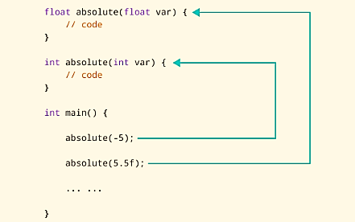
In this program, we overload the absolute() function. Based on the type of parameter passed during the function call, the corresponding function is called.

Example: Overloading Using Different Number of Parameters
Code | Output
#include <iostream>  using namespace std;  // function with 2 parameters  void display(int var1, double var2) {  cout << "Integer number: " << var1;  cout << " and double number: " << var2 << endl;  }  // function with double type single parameter  void display(double var) {  cout << "Double number: " << var << endl;  }  // function with int type single parameter  void display(int var) {  cout << "Integer number: " << var << endl;  }  int main() {  int a = 5;  double b = 5.5;  // call function with int type parameter  display(a);  // call function with double type parameter  display(b);  // call function with 2 parameters  display(a, b);  return 0;  } | Integer number: 5  Float number: 5.5  Integer number: 5 and double number: 5.5

Here, the display() function is called three times with different arguments. Depending on the number and type of arguments passed, the corresponding display() function is called.
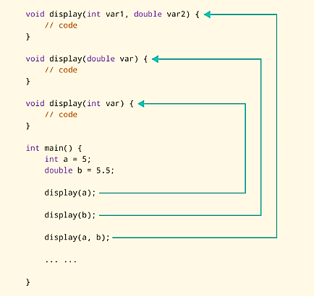
The return type of all these functions is the same but that need not be the case for function overloading.
Note: In C++, many standard library functions are overloaded. For example, the sqrt() function can take double, float, int, etc. as parameters. This is possible because the sqrt() function is overloaded in C++.

C++ Default Arguments
In C++ programming, we can provide default values for function parameters.
If a function with default arguments is called without passing arguments, then the default parameters are used.
However, if arguments are passed while calling the function, the default arguments are ignored.

Working of Default Arguments
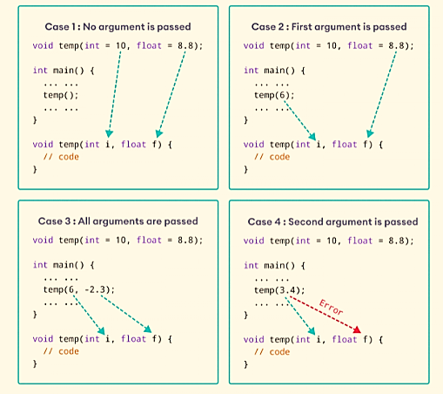
We can understand the working of default arguments from the image above:
- When temp() is called, both the default parameters are used by the function.
- When temp(6) is called, the first argument becomes 6 while the default value is used for the second parameter.
- When temp(6, -2.3) is called, both the default parameters are overridden, resulting in i = 6 and f = -2.3.
- When temp(3.4) is passed, the function behaves in an undesired way because the second argument cannot be passed without passing the first argument.
Therefore, 3.4 is passed as the first argument. Since the first argument has been defined as int, the value that is actually passed is 3.

Example: Default Argument
We have used a for loop to iterate from i = 0 to i = 4. In each iteration, we took an input from the user and stored it in numbers[i].
Then, we used another for loop to print all the array elements.
Code | Output
#include <iostream>  using namespace std;  // defining the default arguments  void display(char = '*', int = 3);  int main() {  int count = 5;  cout << "No argument passed: ";  // *, 3 will be parameters  display();  cout << "First argument passed: ";  // #, 3 will be parameters  display('#');  cout << "Both arguments passed: ";  // $, 5 will be parameters  display('$', count);  return 0;  }  void display(char c, int count) {  for(int i = 1; i <= count; ++i)  {  cout << c;  }  cout << endl;  } | No argument passed: ***  First argument passed: ###  Both arguments passed: $$$$$

Here is how this program works:
- display() is called without passing any arguments. In this case, display() uses both the default parameters c = '*' and n = 1.
- display('#') is called with only one argument. In this case, the first becomes '#'. The second default parameter n = 1 is retained.
- display('#', count) is called with both arguments. In this case, default arguments are not used.
We can also define the default parameters in the function definition itself. The program below is equivalent to the one above.
Code
#include <iostream>
using namespace std;

// defining the default arguments
void display(char c = '*', int count = 3) {
for(int i = 1; i <= count; ++i) {
cout << c;
}
cout << endl;
}

int main() {
int count = 5;

cout << "No argument passed: ";
// *, 3 will be parameters
display();

cout << "First argument passed: ";
// #, 3 will be parameters
display('#');

cout << "Both argument passed: ";
// $, 5 will be parameters
display('$', count);

return 0;
}

Things To Remember
The following program is displaying and printing one-dimensional array.
- Once we provide a default value for a parameter, all subsequent parameters must also have default values. For example,
// Invalid
void add(int a, int b = 3, int c, int d);

// Invalid
void add(int a, int b = 3, int c, int d = 4);

// Valid
void add(int a, int c, int b = 3, int d = 4);
- If we are defining the default arguments in the function definition instead of the function prototype, then the function must be defined before the function call.
// Invalid code
int main() {
// function call
display();
}
void display(char c = '*', int count = 5) {
// code
}

C++ Storage Class
Every variable in C++ has two features: type and storage class.
Type specifies the type of data that can be stored in a variable. For example: int, float, char etc.
And, storage class controls two different properties of a variable: lifetime (determines how long a variable can exist) and scope (determines which part of the program can access it).
Depending upon the storage class of a variable, it can be divided into 4 major types:
- Local variable
- Global variable
- Static local variable
- Register Variable
- Thread Local Storage
A variable defined inside a function (defined inside function body between braces) is called a local variable or automatic variable.

Its scope is only limited to the function where it is defined. In simple terms, local variable exists and can be accessed only inside a function.
The life of a local variable ends (It is destroyed) when the function exits.

Example 1: Local variable
#include <iostream>
using namespace std;
void test();
int main()
{
// local variable to main()
int var = 5;
test();
// illegal: var1 not declared inside main()
var1 = 9;
}
void test()
{
// local variable to test()
int var1;
var1 = 6;
// illegal: var not declared inside test()
cout << var;
}

The variable var cannot be used inside test() and var1 cannot be used inside main() function.
Keyword auto was also used for defining local variables before as: auto int var;
But, after C++11 auto has a different meaning and should not be used for defining local variables.

Global Variable
If a variable is defined outside all functions, then it is called a global variable.
The scope of a global variable is the whole program. This means, It can be used and changed at any part of the program after its declaration.
Likewise, its life ends only when the program ends.

Example 2: Global variable
Code | Output
#include <iostream>  using namespace std;  // Global variable declaration  int c = 12;  void test();  int main()  {  ++c;  // Outputs 13  cout << c <<endl;  test();  return 0;  }  void test()  {  ++c;  // Outputs 14  cout << c;  } | 13  14

In the above program, c is a global variable.
This variable is visible to both functions main() and test() in the above program.

Static Local variable
Keyword static is used for specifying a static variable.

For example:
... .. ...
int main()
{
static float a;
... .. ...
}
A static local variable exists only inside a function where it is declared (similar to a local variable) but its lifetime starts when the function is called and ends only when the program ends.
The main difference between local variable and static variable is that, the value of static variable persists the end of the program.

Example 3: Static local variable
Code | Output
#include <iostream>  using namespace std;  void test()  {  // var is a static variable  static int var = 0;  ++var;  cout << var << endl;  }  int main()  {  test();  test();  return 0;  } | 1  2
In the above program, test() function is invoked 2 times.
During the first call, variable var is declared as static variable and initialized to 0. Then 1 is added to var which is displayed in the screen.
When the function test() returns, variable var still exists because it is a static variable.
During second function call, no new variable var is created. The same var is increased by 1 and then displayed to the screen.
Output of above program if var was not specified as static variable

Lab Tasks
Circuit Sensor Array Processor
Scenario: A circuits lab records voltage readings from 5 sensors placed along a distribution line.

(a) Passing a 1D Array to a Function
Write void displayReadings(float readings[], int size) that prints every sensor's voltage. Test with readings = {228.5, 231.2, 229.8, 225.0, 232.6}.
#include <iostream>
using namespace std;

// TODO: write void displayReadings(float readings[], int size)

int main()
{
float readings[5] = {228.5, 231.2, 229.8, 225.0, 232.6};
// TODO: call displayReadings(readings, 5)
return 0;
}
Expected Output
Sensor 1: 228.5 V
Sensor 2: 231.2 V
Sensor 3: 229.8 V
Sensor 4: 225 V
Sensor 5: 232.6 V

(b) Returning a Value Derived From an Array
Write float findMaxVoltage(float readings[], int size) that returns the highest voltage in the array.
Expected Output
Maximum voltage recorded: 232.6 V

(c) Function Overloading (by number of parameters)
Write void reportStatus(float voltage) that compares against a fixed threshold of 230 and prints HIGH or Normal. Then overload it as void reportStatus(float voltage, string sensorLabel) that includes the sensor's label in the message.
// TODO: void reportStatus(float voltage)
// TODO: void reportStatus(float voltage, string sensorLabel)

int main()
{
// TODO: call reportStatus(232.6);
// TODO: call reportStatus(225.0, "Sensor 4");
return 0;
}
Expected Output
Voltage 232.6 V: HIGH
Sensor 4 - Voltage 225 V: Normal

(d) Default Arguments
Write void checkOverload(float voltage, float limit = 230.0) that warns if voltage exceeds limit. Call it once without a custom limit, and once with a custom limit of 235.
Expected Output
232.6 V exceeds limit of 230 V -> Overload Warning!
225 V is within limit of 235 V -> OK

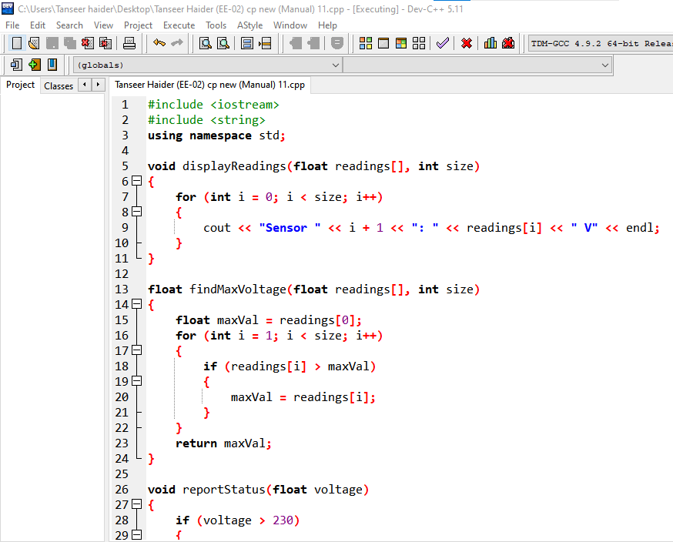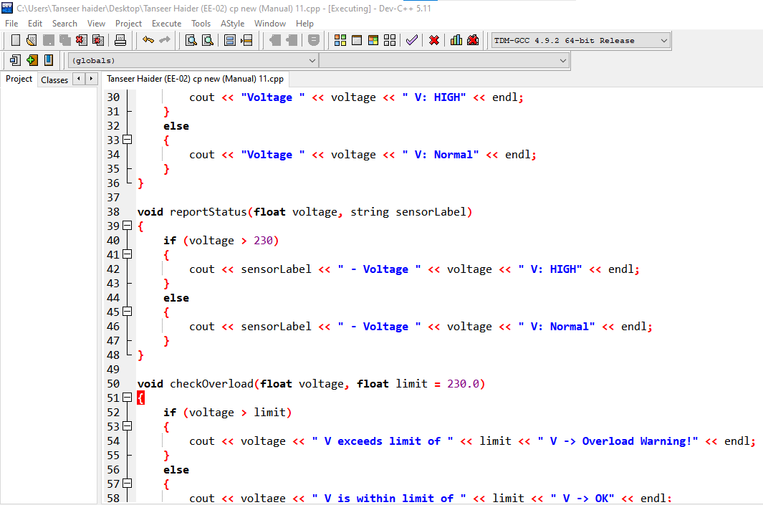
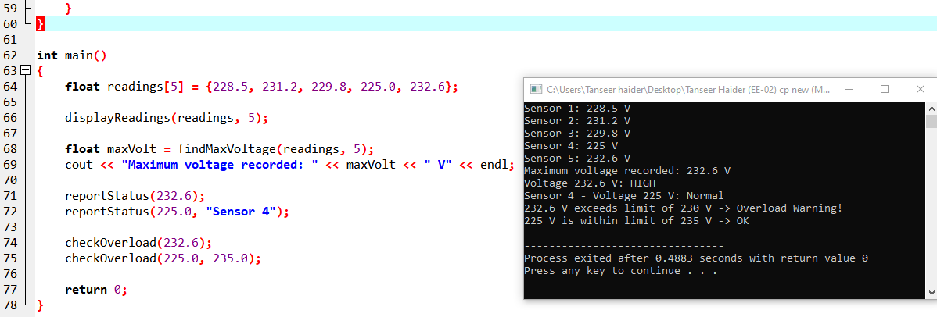

5 Home Task
Multi-Feeder 2D Voltage Grid Analyzer
Scenario: A substation records hourly voltage readings from 3 feeders, 4 hours each: int grid[3][4] = { {220,218,225,221}, {230,229,228,231}, {215,217,216,214} };

(a) Passing a 2D Array to a Function
Write void displayGrid(int grid[][4], int rows) that prints every feeder's readings, labeled by feeder and hour.
Expected Output (excerpt)
Feeder 0, Hour 0: 220
Feeder 0, Hour 1: 218
...
Feeder 2, Hour 3: 214

(b) Returning a Value Derived From a 2D Array
Write float averageVoltage(int grid[][4], int rows) that returns the overall average of all 12 readings.
Expected Output
Overall average voltage: 222 V

(c) Static Local Variable
Write int diagnosticCount() with a static int inside that increases by 1 every time the function is called, and returns the new count. Call it three times from main() and print each result.
// TODO: int diagnosticCount() using a static local variable

int main()
{
// TODO: call diagnosticCount() three times and print each result
return 0;
}
Expected Output
Diagnostic check #1
Diagnostic check #2
Diagnostic check #3

(d) Global Variable
Declare a global variable int totalReadingsProcessed = 0; above main(). Increase it by 1 inside displayGrid() for every reading printed, then print its final value in main() after calling displayGrid().
Expected Output
Total readings processed so far: 12
